Supplementary Materials

Figure S.1. Histogram of participant age.

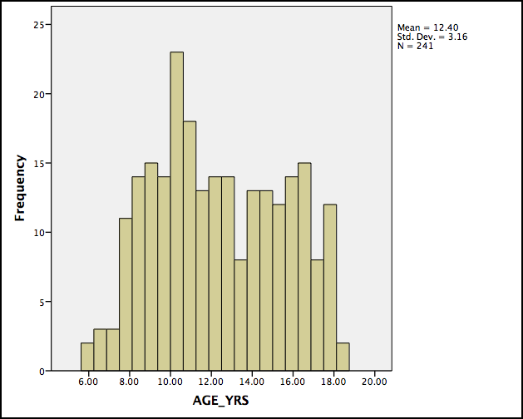

Figure S.2. Example plot of raw fractional anisotropy data. Plots display relations between age and unadjusted mean FA of left SLF at varying levels of CBCL A/D (i.e., median and below, above median) for both males and females.

